Course Name: | Web Development Laboratory | Semester: | III
Date of Performance: | 3 / 8 / 2026 | DIV/ Batch No: | A1
Student Name: | Mrudul Bhagwat | Roll No: | 16010125020
Experiment No: 1
Title
Design and Development of an AI-based Smart Irrigation Advisory Web Portal Front-End using HTML5
Aim of the Experiment
To design and develop a multi-page, use-case-based web portal front-end using HTML5 for an AI-based Smart Irrigation Advisory System for Sugarcane Crop (KJS-AGR-01), demonstrating proper HTML5 document structure, semantic elements, formatting, lists, hyperlinks, images, image maps, tables, forms, and multimedia elements.
Objectives of the Experiment
- To develop structured and semantic HTML5 web pages for an AI-enabled smart irrigation advisory system.
- To create interactive web pages for farmer registration, irrigation recommendations, weather information, crop monitoring, and advisory services.
- To apply a real-world AI and IoT-based agriculture use case (Smart Irrigation Advisory System) as the context for front-end web development.
- To build a complete HTML5 front-end portal that can later be enhanced using CSS3, JavaScript, PHP, and React.
COs to be achieved
CO1: Developing webpages using HTML and CSS.
Books / Journals / Websites references
- https://developer.mozilla.org/en-US/docs/Web/HTML/Reference/Elements
- https://www.w3schools.com/html/

Theory
HTML5 is the latest version of HyperText Markup Language used to create structured and interactive web pages. It introduces semantic elements such as <header>, <nav>, <main>, <section>, <article>, and <footer>, making web pages more organized, accessible, and search-engine friendly.
HTML5 also provides support for multimedia elements like <audio> and <video>, interactive forms, tables, hyperlinks, image maps, and embedded content through <iframe>. These features help developers create user-friendly web applications for various domains such as healthcare, education, business, and agriculture.
In this experiment, HTML5 is used to design the front-end of an AI-based Smart Irrigation Advisory System. The portal enables farmers to register their farms, view irrigation schedules, monitor weather conditions, access crop information, receive AI-generated irrigation recommendations, and visualize farm locations. The application serves farmers, agricultural officers, researchers, and sugar factory management by providing organized and easy-to-understand agricultural information.
Problem Statement

"AI-based Smart Irrigation Advisory Web Portal"
An agricultural organization wants to develop a basic HTML5-based web portal front-end for an AI-based Smart Irrigation Advisory System. The portal should display farm information, soil moisture status, weather forecasts, irrigation recommendations, crop information, and advisory services for farmers, agricultural officers, researchers, and sugar factory management.
Each task below contributes one page or feature of this portal, representing different modules of the Smart Irrigation Advisory System.
Task 1: Create the Homepage Structure
Scenario
Design the homepage of the Irrigation Advisory System.
Requirements
- Use proper HTML5 document structure tags:
  - <header>, <nav>, <section>, <article>, <aside>, <footer>
- Header must contain:
  - System Name in <h1>
  - Tagline: "Smart Irrigation using AI & Sensor Technology"
- Navigation menu with links:
  - Home
  - Farm Dashboard
  - Irrigation Advisory
  - Sensor Data
  - Contact
- Footer with copyright information.
Concepts Tested
- HTML5 document structure
- Semantic tags
- Headings
- Hyperlinks
Deliverable: index.html

Task 2: Display Farm Information using Lists
Scenario
Display important farm information and irrigation resources.
Requirements
Create:
- Ordered List for
  - Irrigation Workflow
- Unordered List for
  - Sensors Used
    - Soil Moisture Sensor
    - Temperature Sensor
    - Humidity Sensor
    - Rainfall Sensor
- Description List for
  - Crop Stages
    - Germination
    - Tillering
    - Grand Growth
    - Maturity
Use formatting tags:
- <b>
- <i>
- <mark>
Concepts Tested
- Lists
- Formatting tags
- Text formatting
Deliverable: farm-info.html

Task 3: Irrigation Advisory Page using Formatting Tags
Scenario
Display today's irrigation recommendation for a sugarcane field.
Requirements
Display:
- Plot ID
- Farmer Name
- Soil Moisture
- Recommended Irrigation Duration
- Water Stress Level
Use:
- <strong>
- <em>
- <mark>
- <small>
- <br>
- <hr>
Concepts Tested
- Text formatting
- Block-level elements
- Inline formatting
Deliverable: advisory.html

Task 4: Farm Gallery using Images
Scenario
Create a gallery showing different farm conditions.
Requirements
Display four images:
- Healthy Sugarcane Crop
- Drip Irrigation System
- Soil Moisture Sensor
- Weather Monitoring Station
Each image should:
- Open detailed information when clicked
- Include:
  - alt
  - title
  - width
  - height
Use:
- <figure>
- <figcaption>
Concepts Tested
- Images
- Hyperlinks
- Global attributes
Deliverable: gallery.html

Task 5: Farm Plot Navigation using Image Map
Scenario
Provide navigation to different farm plots.
Requirements
Display a farm map.
Create clickable areas for:
- Plot A
- Plot B
- Plot C
Each area should open the corresponding plot details.
Use:
- <map>
- <area>
Concepts Tested
- Image Maps
- Hyperlinks
Deliverable: plot-map.html

Task 6: Soil Moisture & Irrigation Table
Scenario
Display irrigation recommendations for multiple plots.
Requirements
Create a table with columns:
- Plot ID
- Farmer Name
- Soil Moisture (%)
- Weather
- Irrigation Recommendation
- Water Requirement
Use
- <caption>
- <thead>
- <tbody>
- <tfoot>
- rowspan
- colspan
Apply suitable formatting.
Concepts Tested
- HTML Tables
- Table Attributes
Deliverable: irrigation-table.html

Task 7: Farmer Registration Form
Scenario
Create a registration page for farmers.
Requirements
Use form controls:
- Name
- Mobile Number
- Email
- Plot ID
- Village
- Crop Stage
- Soil Type
- Irrigation Method
- Date
- File Upload (Farm Photo)
Include
- <label>
- <fieldset>
- <legend>
Use HTML5 attributes
- required
- placeholder
- pattern
- autofocus
Concepts Tested
- HTML Forms
- HTML5 Input Types
- Validation Attributes
Deliverable: registration.html

Task 8: Display Weather Forecast using IFrame
Scenario
Display weather information without leaving the website.
Requirements
Embed
- IMD Weather Forecast page
- Google Maps showing the farm location
Use
- <iframe>
Place inside a section called
Today's Weather Forecast
Concepts Tested
- Inline Frames
- External Content Integration
Deliverable: weather.html

Task 9: Add Multimedia & Executable Content
Scenario
Create a multimedia awareness page for farmers.
Requirements
Add
- A video explaining Smart Irrigation
- Background audio explaining water conservation
- JavaScript alert
Welcome to the Irrigation Advisory System
Use
- <video>
- <audio>
- <script>
Enable
- controls
- autoplay
- loop
Concepts Tested
- Multimedia Tags
- JavaScript
- Executable Content
Deliverable: media.html

Code :
GitHub Repository :https://github.com/mrudul2505/AI-based-Smart-Irrigation-Advisory-Kisan-Sathi-
Live Website : https://smartirrigation-brown.vercel.app/

Output / Screenshot:
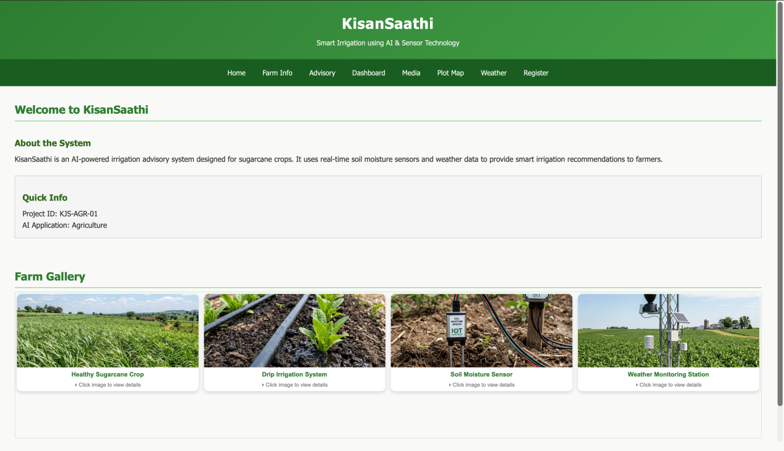
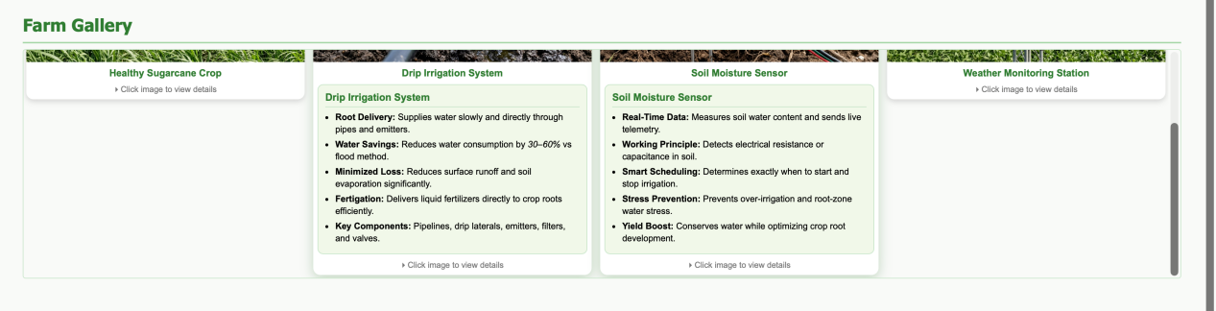
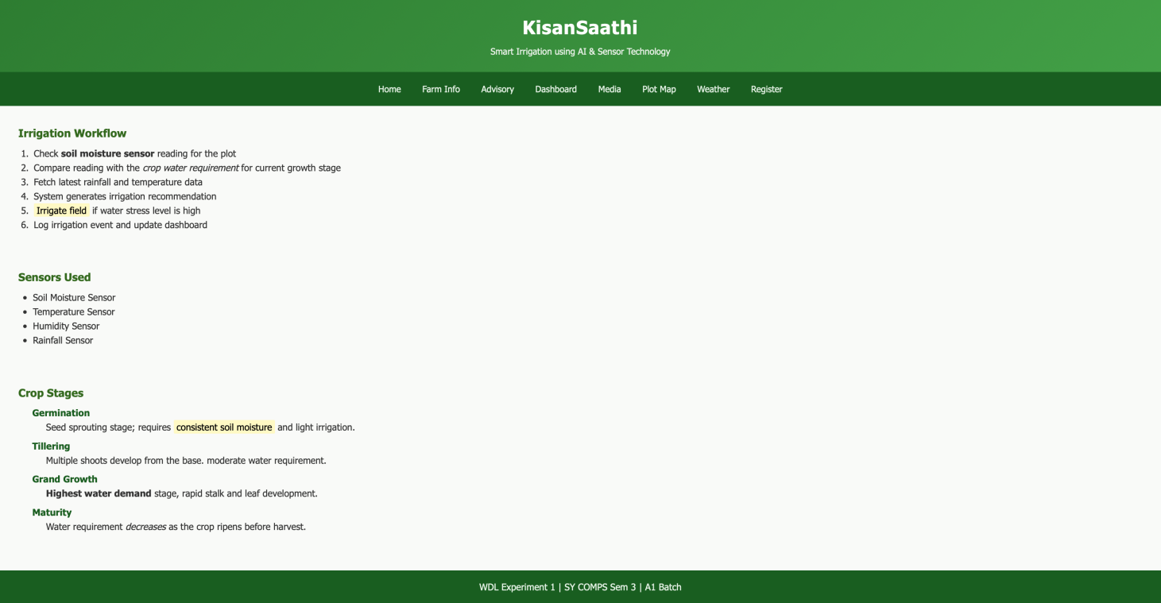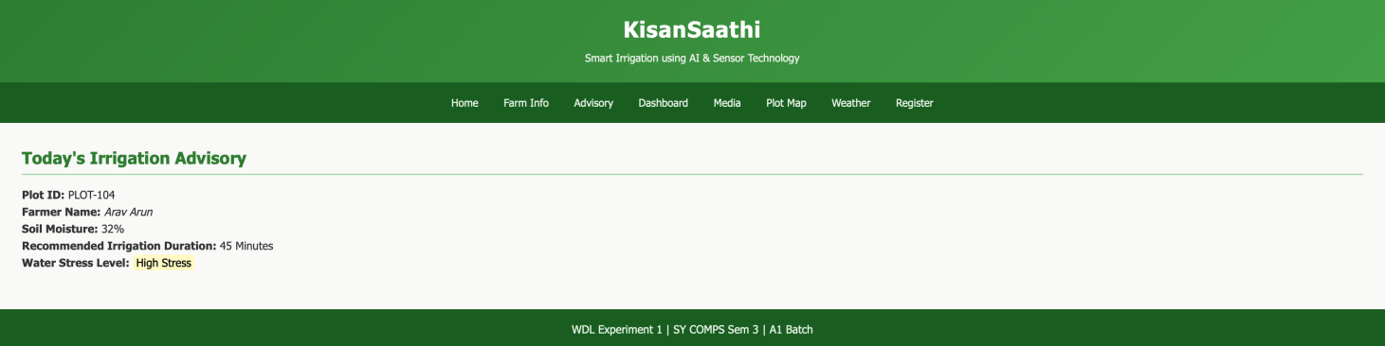
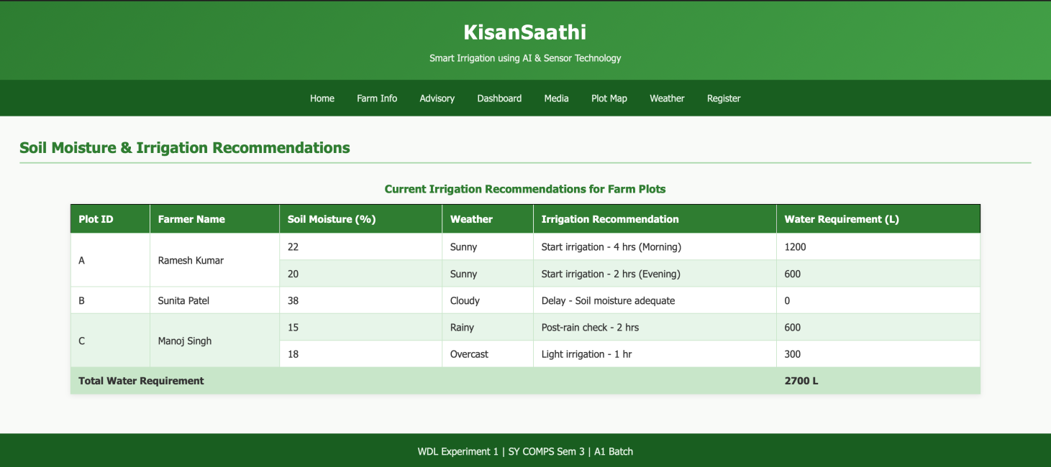
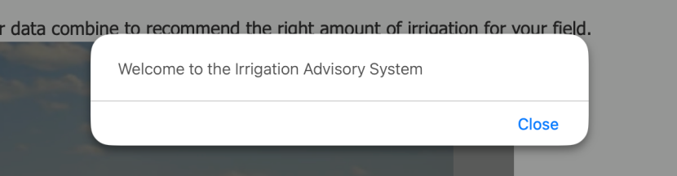
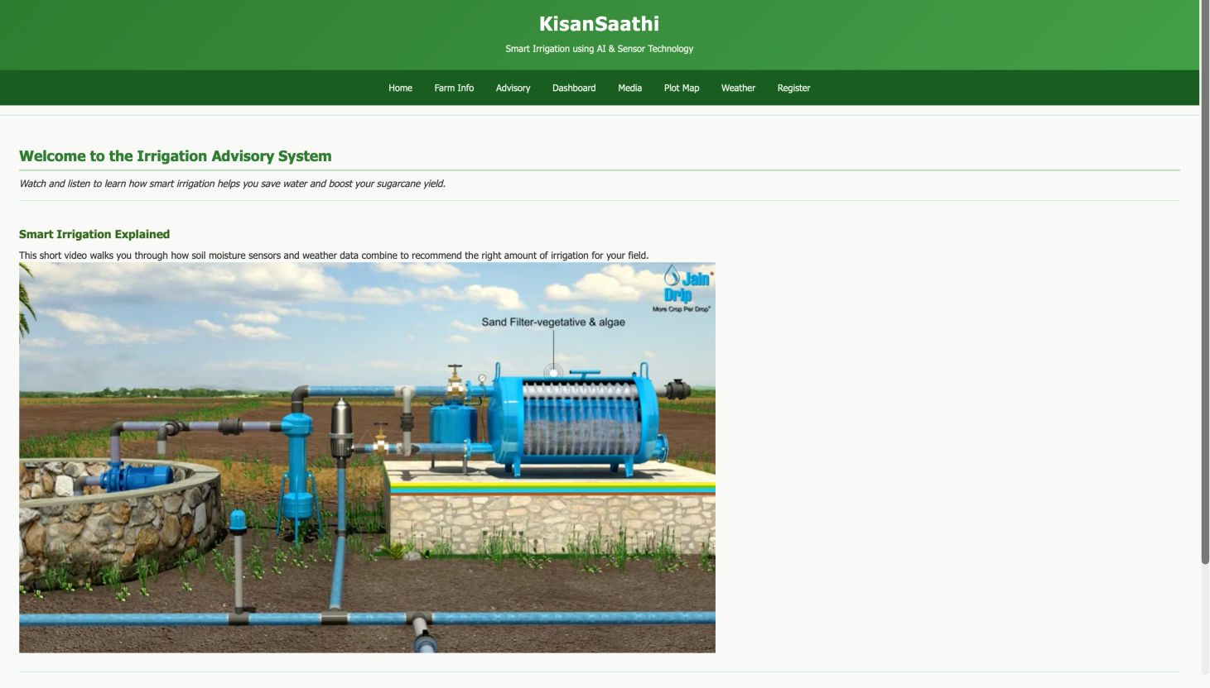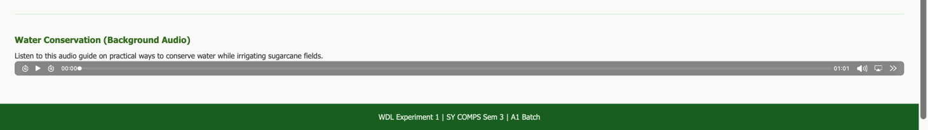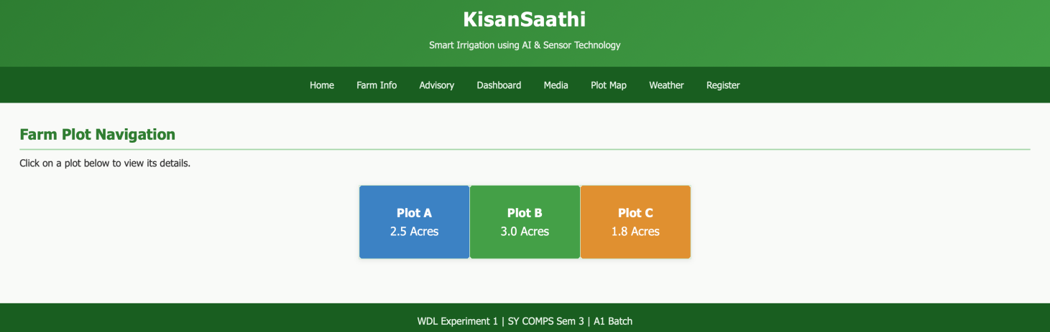
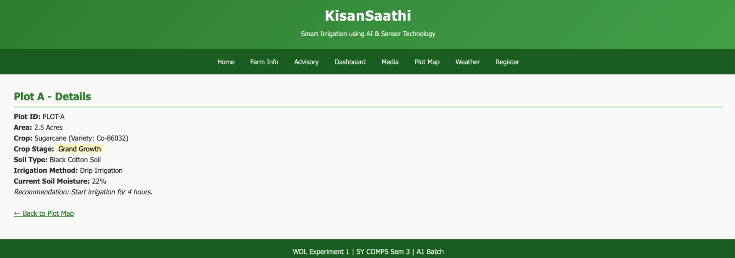
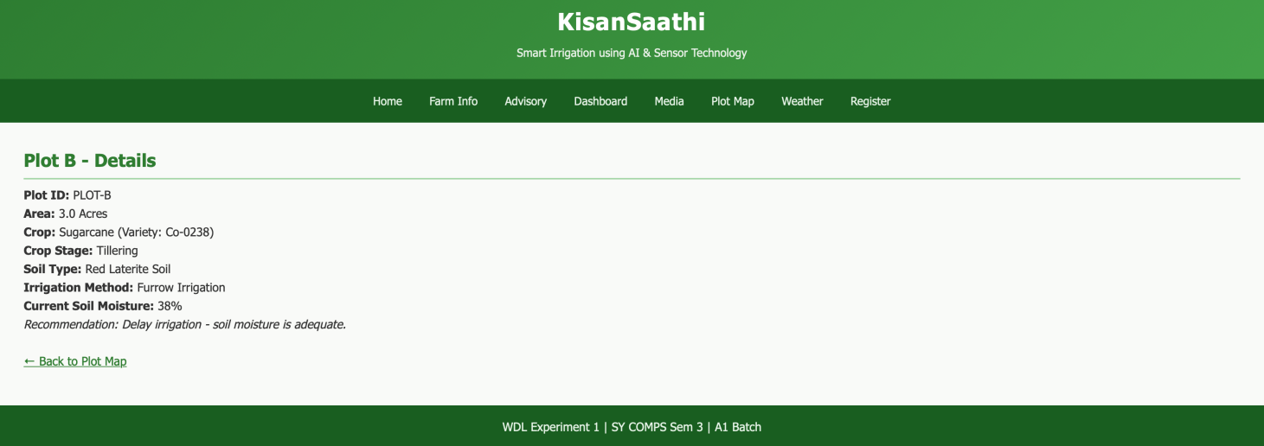
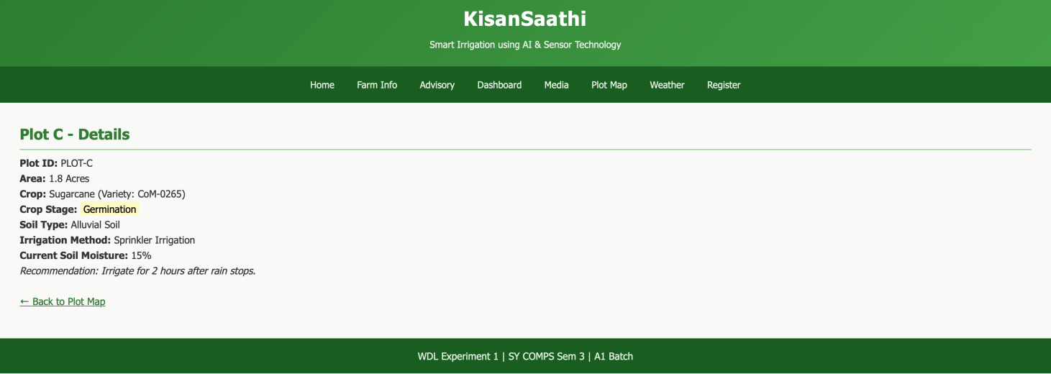
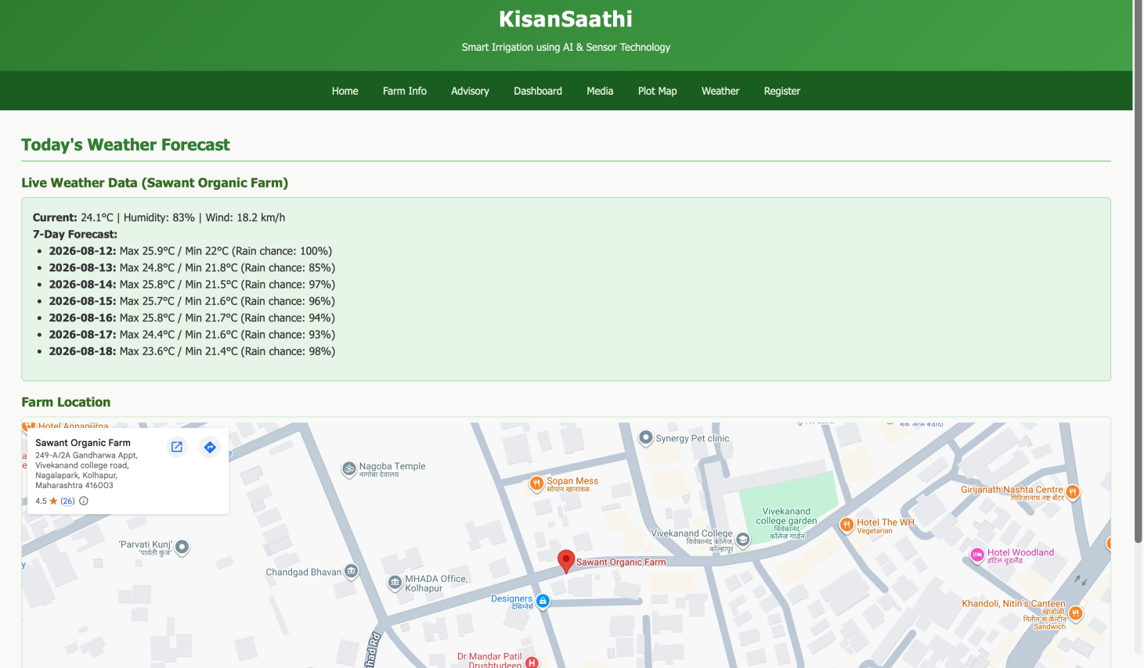
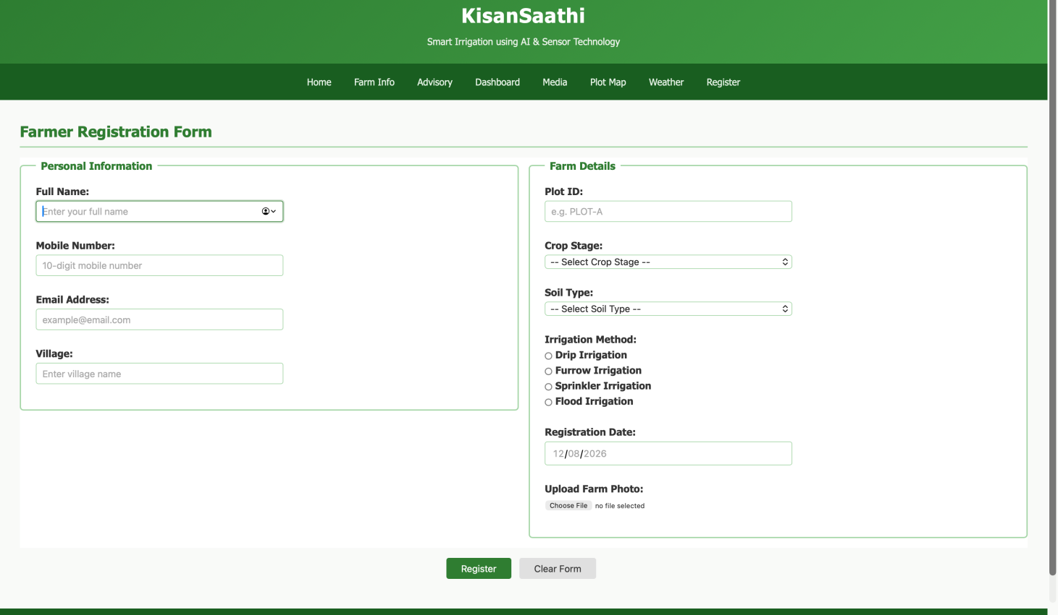

Conclusion and Discussion:
The experiment demonstrated the design and development of a multi-page AI-based Smart Irrigation Advisory Web Portal using HTML5.
- Implemented proper HTML5 semantic structure using elements such as <header>, <nav>, <section>, <article>, <aside>, and <footer>.
- Used lists, formatting tags, hyperlinks, images, image maps, and tables to organize and present agricultural information effectively.
- Developed a farmer registration form using HTML5 input types and validation attributes such as required, pattern, placeholder, and autofocus.
- Integrated weather information and farm location using <iframe>.
- Added multimedia content using video, audio, and alert functionality.
- The experiment provided practical understanding of how HTML5 can be used to build the front-end of a real-world smart agriculture and IoT-based application.

